
BDL portal map user manual
version 3.55

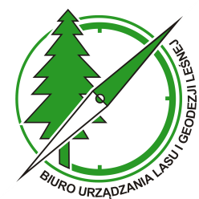

Sękocin Stary, september 2025

Table od contents

1. Tools available on the BDL interactive map: 5
2. BDL Maps 6
3. BDL Basemaps 7
4. Navigation on the BDL map 8
5. Identify tool 9
6. Measure tool 11
6.1. Area measure 11
6.2. Distance measure 13
6.3. Location 14
7. Stand description 17
8. Print map 19
9. Search tool 20
10. Permalink 25
11. Share location 26
12. Copy coordinates 27
13. WMS/WMTS maps 28
14. Loading and handling SHP/KML/GPX files 31
15. Legend 33
16. Reading selected information from the map 34
17. How to find areas for Spend the night in the forest? 36
18. Language 38
19. Help 39

Tools available on the BDL interactive map:
Permalink - Allows you to generate a link to the current map view, which can be easily shared with other users.
 Stand description - Displays detailed information about the selected forest compartment, such as tree species, address data, and economic indicators.
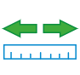 Distance - Used to measure the distance of the selected area with the ability to edit points and change units.
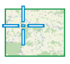 Location - Allows you to read the coordinates of a selected point on the map in the selected reference system.
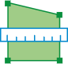 Area - Used to measure the area of the selected area with the option to edit points and change units.
 Print map - Allows you to generate a file with the selected map area in JPG or PDF format.
 Search - Allows you to search for locations on the map by name, forest address, cadastral parcel, coordinates, or address points.
 Identify - Displays information about the selected area on the map depending on the thematic layer.
 Help - A guide to the map's functions and tools, facilitating the use of the portal.

BDL Maps
The default map in the BDL portal is the basic map. To change it, select “BDL Maps” in the bottom bar of the interactive map. The screen will display 14 thematic maps:
- Standard map
- Map of categories of property
- Forest stands map
- Forest site map
- Plant communities map
- Map of hunting
- Forest fire danger map
- Forest entry prohibited map
- Tourist infrastructure map
- Protective type map
- Forest management
- Fire roads
- Forest Monitoring
- Wzmocnienie ochrony zasobów leśnych

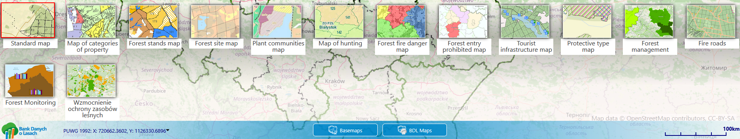

BDL Basemaps
As with thematic maps, there is also a “Basemaps” tab on the toolbar. Users can change the background of the forest maps displayed by clicking on the map tile they are interested in. There are 8 backgrounds available:
- Imagery Hybrid
- Topographic with contour
- Topographic
- Navigation
- Terrain with Labels
- Light Gray Canvas
- ESRI OpenStreetMap
- Orthophoto map of Poland
- OpenStreetMap

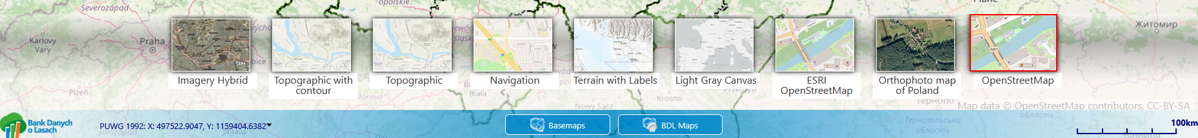

Navigation on the BDL map
By clicking on the “Find my location”... icon, you can check your approximate location. The portal will automatically zoom in on the user's location.
The “zoom in”  and “zoom out”  icons are used to zoom in and out on the map.
By selecting “Zoom to full extent,”  the user returns to the view of the entire country, which makes it easier to select a new area without having to zoom out repeatedly.
By clicking on “Zoom in”  you can zoom in on the selected area on the map.
Using the “Previous view”  arrow, you can return to the previous map range.
The “Next view”  arrow scales the map to the next range.

Identify tool
The “Identify”....tool allows you to display information about a selected point by clicking on the map. From the drop-down list, the user should select the topic about which they want to obtain information.

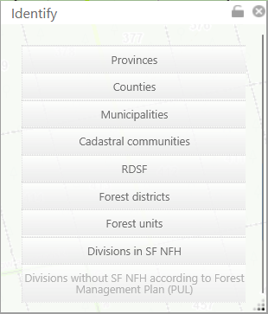

Additionally, using the “Zoom to” option, you can zoom in on the map to view the entire selected element. Information is read only for active (enabled) layers. If a layer is disabled, it will not be included by the “Identify” tool and will not be displayed in the results.

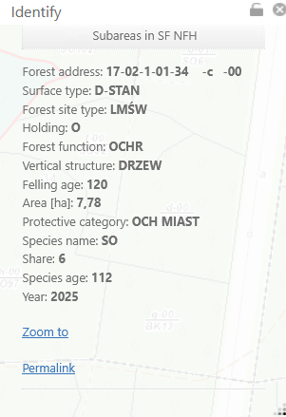

It is also possible to move or lock the position of the “Identify” window. Locking is possible using the padlock visible in the upper right corner of the window.

Measure tool

Area measure
After activating the “Area” tool and indicating the breakpoints (minimum 3) on the map, the measure result is visible in the right panel. Additionally, the tool allows you to measure several polygons simultaneously. Each new measure is added as a separate object, and the total area is displayed in the panel on the right.

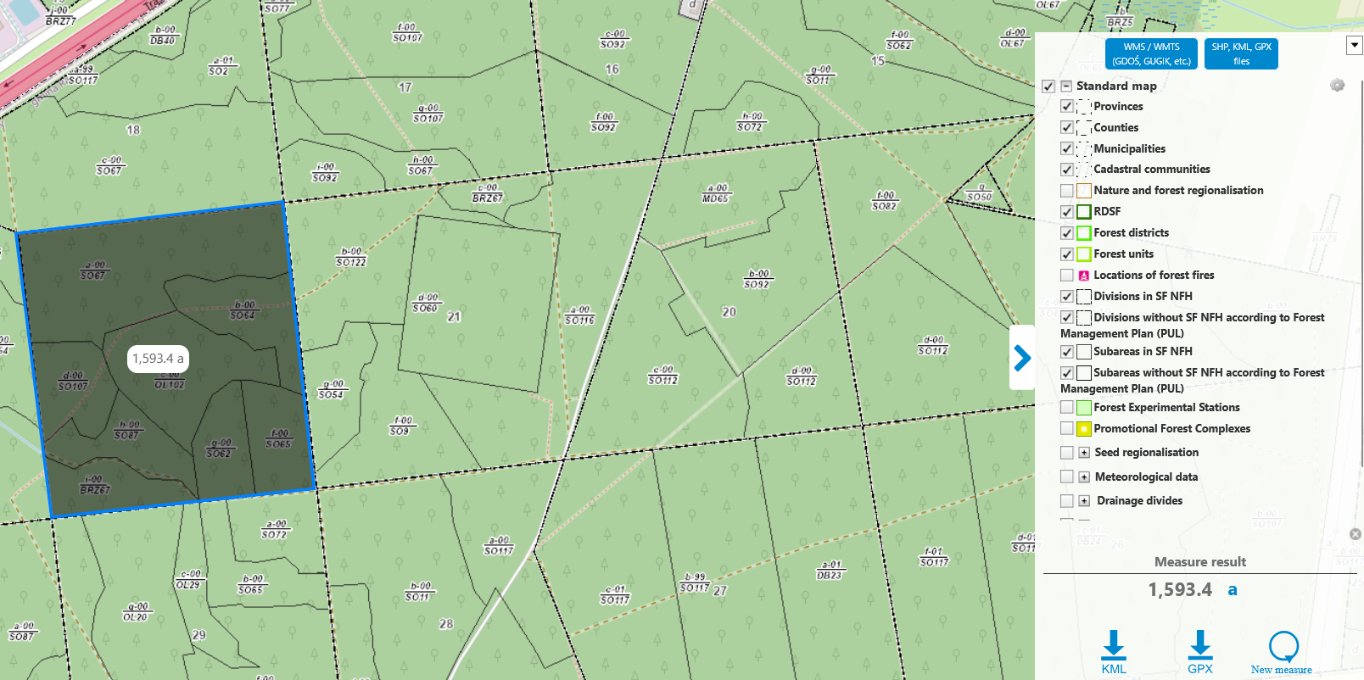

On the map, it is also possible to move measure breakpoints, both during and after measure. To do this, simply click on the point and then move it to the desired location. It is also possible to change the measure units, e.g., to m², ha, a, or km². To do this, click on the measure unit visible in the right corner of the map, and then select the unit to which the result visible on the map or in the “Measure result” window is to be converted from the drop-down list.

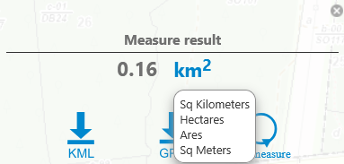

The measure can also be exported to a KML  or GPX  file.
To remove previous measure from the map, right-click anywhere on the map and select “New measure”

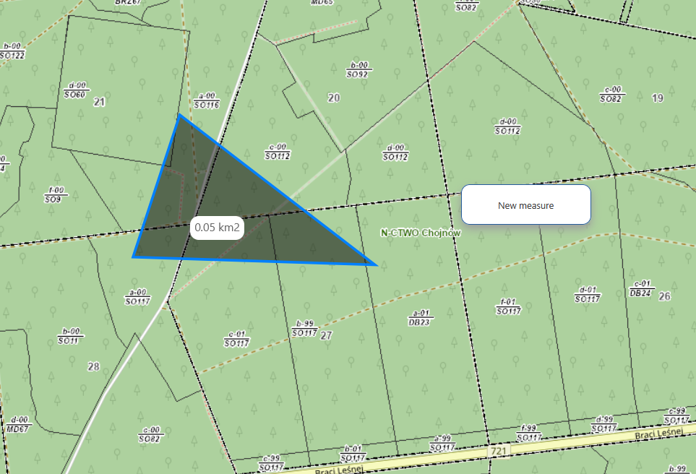

Another way to delete the entire measure is to click on the icon  in the right panel.
If several measure have been taken at the same time, a single measure can be deleted using the “Delete selected measure” option available under PPM.
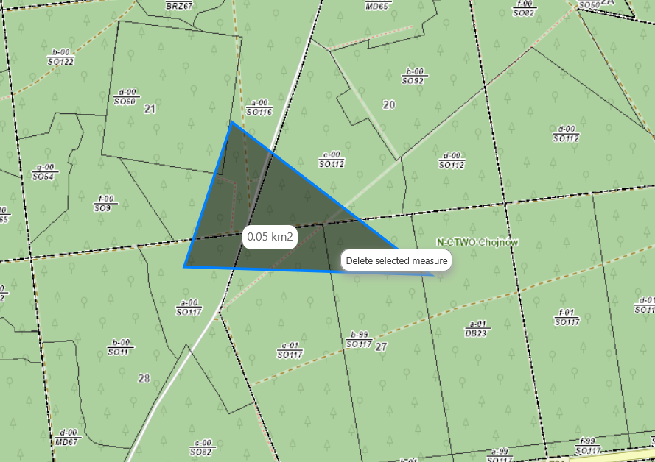

Distance measure
To measure distances on the map, select the “Distance” tool. As with area measure, you can export the measure result to a KML/GPX file or delete it from the map. It is also possible to edit the drawn line – measure points can be moved both during drawing and after completing the measure. In addition, the tool allows you to measure several lines simultaneously. Each new line is treated as a separate measure, and the total length of the measure is displayed in the right side panel.

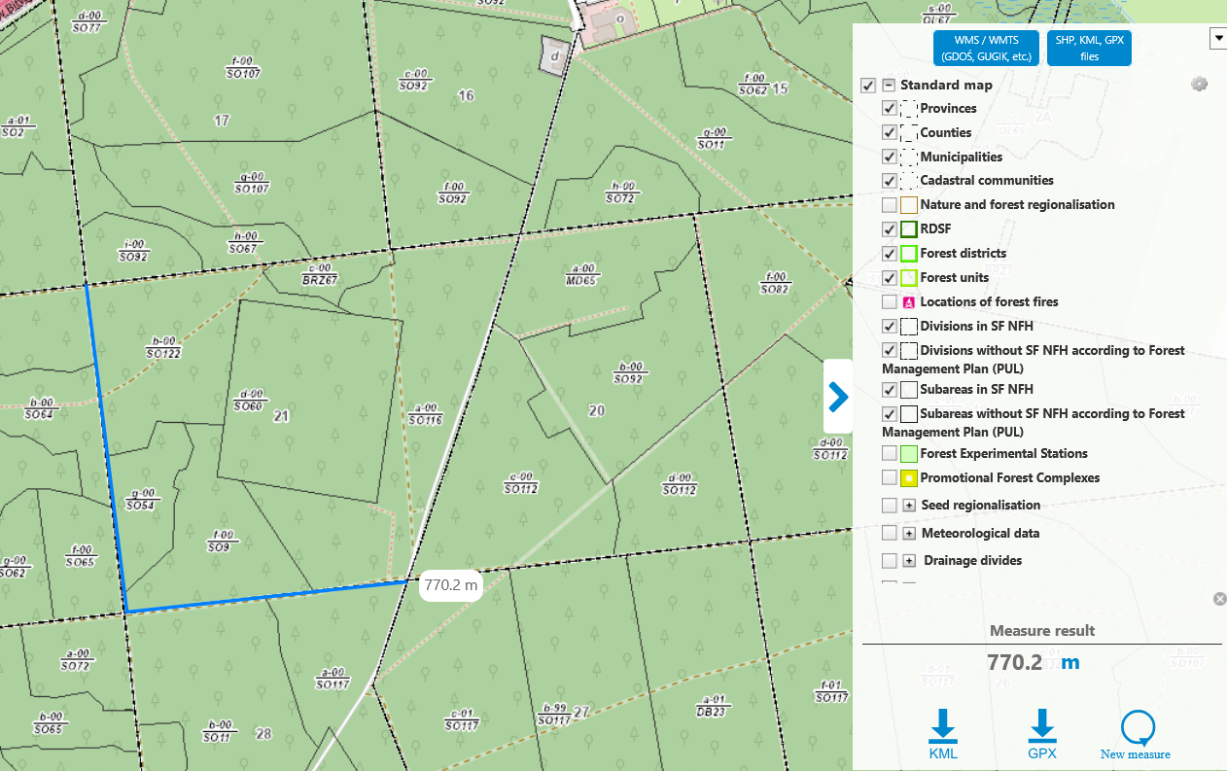

Location
To read the coordinates of any point indicated on the map, use the “Location” tool. Use the mouse cursor to select the point of interest whose coordinates you want to display in the window on the right side of the BDL portal.

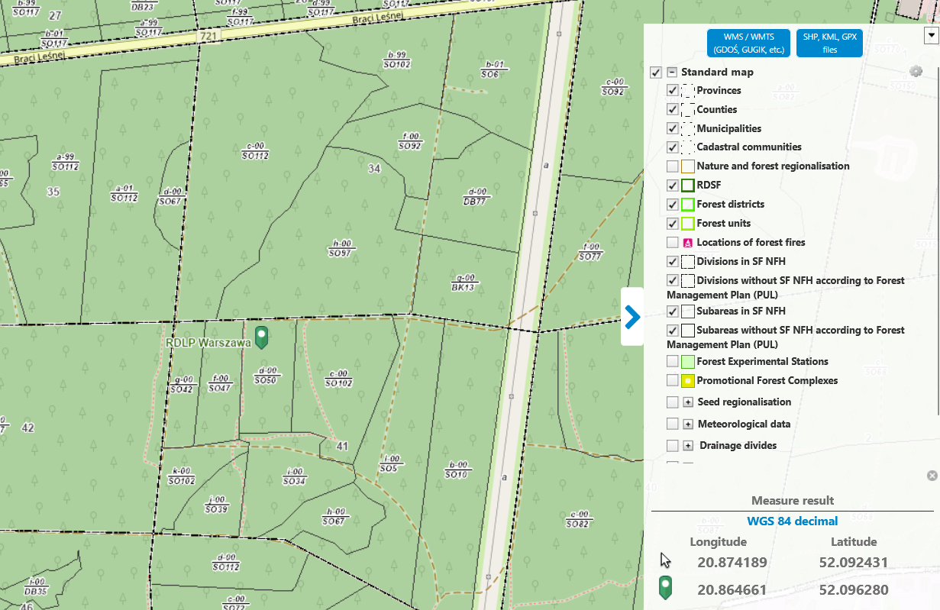

The user can change the coordinate system to:
• WGS 84 decimal
• WGS 84 degrees
• PUWG 1992
To do this, go to the right panel of the map and click on the coordinate system visible under the measure result. A list of available systems will then expand, and the coordinates of the point previously marked on the map will be displayed below.

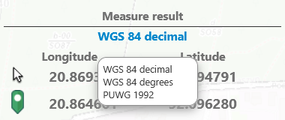

When you click on the map, you will notice that the coordinates of the cursor and the teardrop are identical.
When you move the mouse cursor over the interactive map, the coordinates displayed in the first row of results change. However, the coordinates of the teardrop remain unchanged until the user clicks on the selected point on the map again.

Stand description
To check the stand description of the subareas, click on the “Stand description” tool. Click with the mouse cursor on the map where the tree stand/forest compartment is located. A window will appear on the map displaying address data, general data, and information about layers, species, or economic indicators for the subareas compartment.

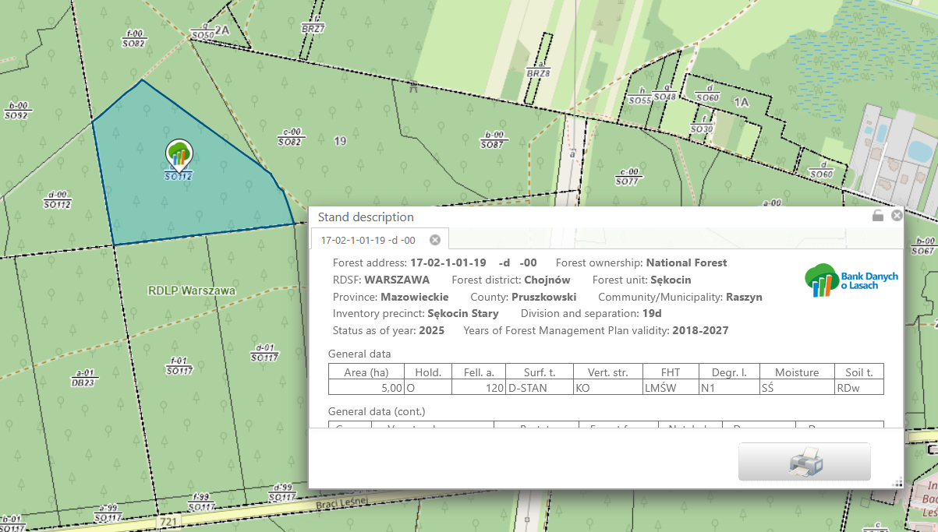

In the same window, you can also check the explanations of individual codes – just
hover your cursor over the selected abbreviation to display its meaning.
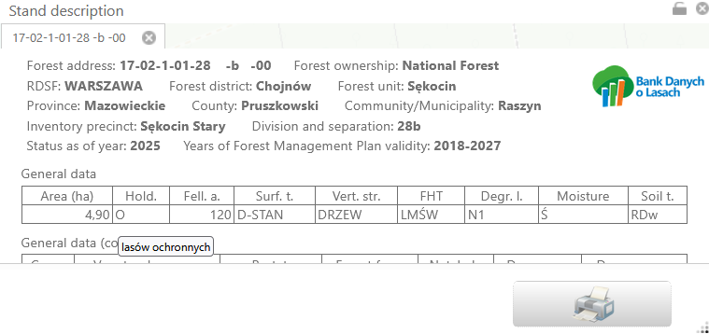

The description can be printed in various formats, e.g., PDF or jpg, and in various orientations. After subareas from the map, the following option will appear: print all descriptions or only the active one. Printing all descriptions means saving all generated descriptions to a file, while printing the active one means saving only the description for one active subareas to a file.

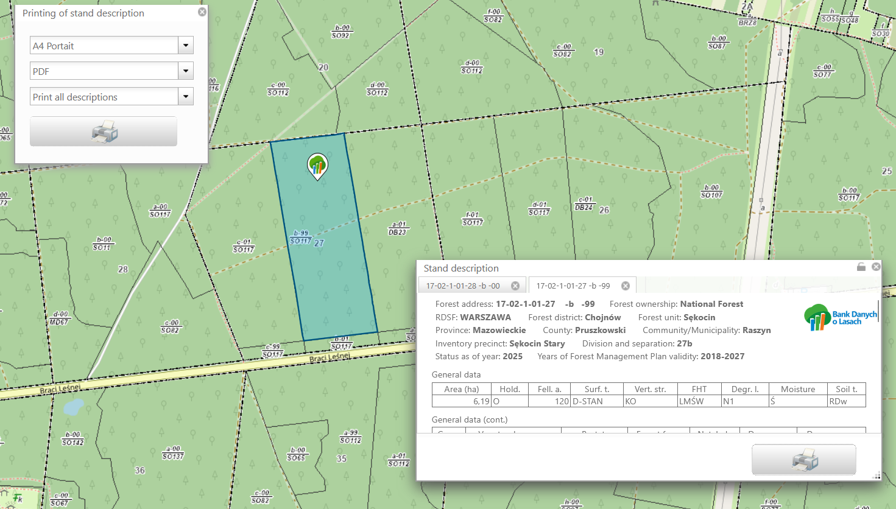

The stand description window can be moved in any direction. After clicking the padlock icon, its position will be locked and it will remain in the selected location.

Print map
Using the “Print map” tool, users can generate a printout of a selected area of the map. From the “Print map” window, select the format and scale, and then select the print range on the interactive map by clicking the “Select range” button. The selected range can be moved in any direction on the map. After making your selection, click on the printer icon, and the portal will automatically generate the map to a file.

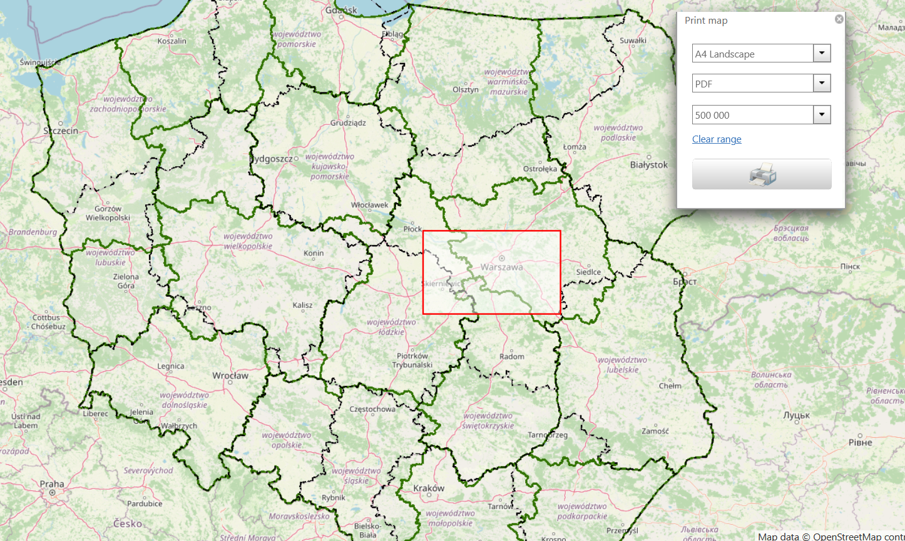

Search tool
To search the map by various data ranges (object names, forest addresses, cadastral parcels, coordinates), use the “Search” tool.
In the first tab, “Text,” the user can search for data by name in individual layers visible on the map. Simply enter the name in the upper text field and click the “Search” button. The search results will be displayed in the window, and after double-clicking on the description of the place, the map will zoom in on the selected point. Additionally, the user can narrow down the results by using the “Limit search to layer” option, selecting the thematic layer of interest from the drop-down list.

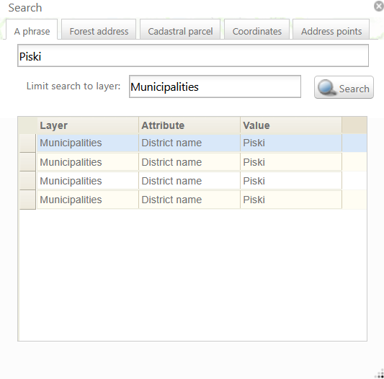

In the “Forest address” tab, you can search for objects by forest addresses assigned to different forms of forest ownership:
• State Treasury forests managed by State Forest,
• State Treasury forests managed by other agencies,
• Forests of other forms of property.
When searching for State Forest, the “Search” button is available after selecting a unit from the RDSF list; it is not necessary to enter the entire forest address. In this way, the user can search not only for a subareas, but also for higher-level objects such as: RDSF, inspectorate, forest district, forestr range, or forest compartment.

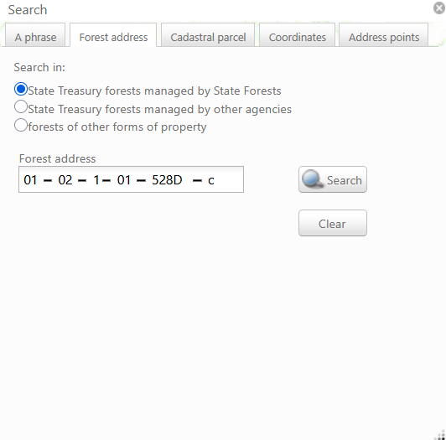

In the “ Cadastral parcel” tab, you can search for cadastral parcel by ID. To do this, select the province, county, municipality, and cadastral comm. from the list and enter the known cadastral parcel number. After filling in all the fields, click the Search icon to go to the search results and display the selected cadastral parcel t on the map.
In the “ Ident. of parcel (optional)” field, you can also enter the entire identifier without having to select it from the province to the cadastral comm.. Finally, just click the “Search” button, as in the previous search.

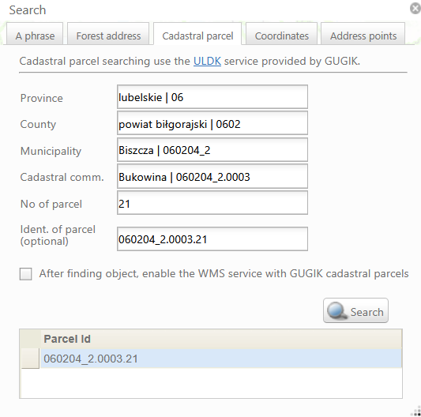

In the “Coordinates” tab, you can search for a point's location using coordinates. Enter the geographic coordinates in the selected coordinate system – WGS 84 in two variants or PUWG 1992 – and click „Search” to display the point on the map.

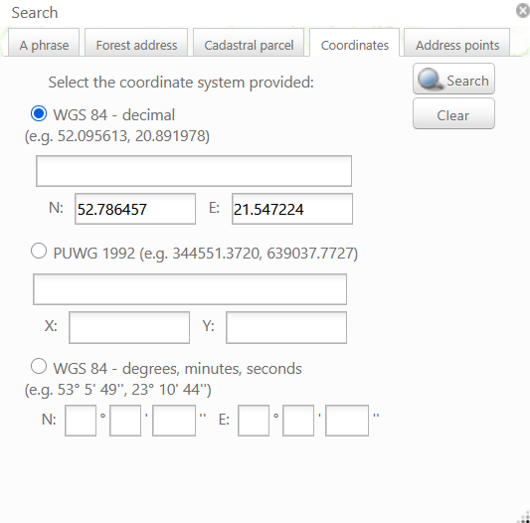

In the last tab of the “Address Points” window, the user can search for locations based on their address, using various data entry options. Depending on the information available, the address field can be filled in by entering: the name of the town, the name of the town and street, the name of the town and number, or the name of the town, street, and number. After entering the data in the selected variant, click the Search button for the portal to find the location. You can zoom in on the searched location by double-clicking on the place description in the “Search” window.
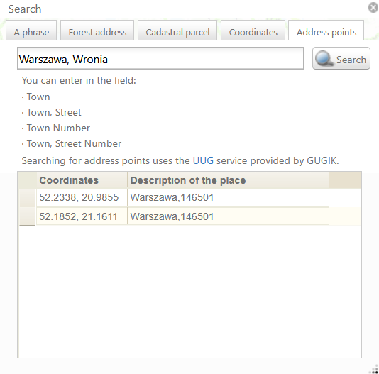

Permalink
By selecting the “Permalink” tool, we can copy the URL leading to the current view and status of the map. After clicking , the generated link will be automatically copied to the clipboard. The user can paste the permalink into the browser window, and will then be automatically redirected to the main window of the BDL portal, where the previously shared map range will be displayed. The permalink stores the type of active BDL map, the type of background, information about which layers are active, and the geographical range of the map to be displayed. The generated link can also be shared with other users. It is also possible to generate a permalink for a subareas from the “Identify” tool. To do this, select the area of interest on the BDL interactive map and click on it with the mouse cursor, then expand “Subareas in SF NFH” or “ Subareas without SF NFH according to Forest Management Plan (PUL)” from the Identify list and click “Permalink”. The link will be copied to the clipboard and, when pasted into the browser, will open a map with the subareas marked.

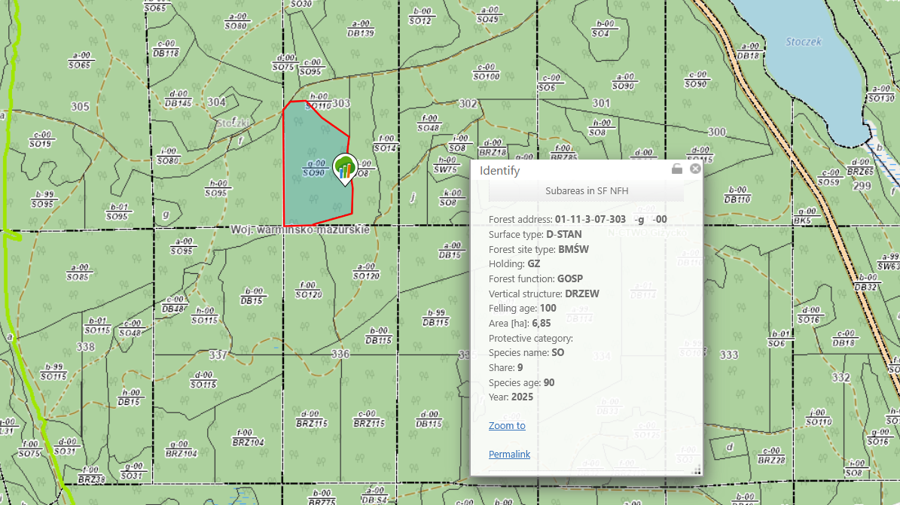

Share location
The interactive map on the BDL portal allows you to share a selected location. To do this, right-click on the selected location on the map, then select the “Share location” option from the menu that appears. The link to the selected point will be copied to the clipboard, which you can then paste into your browser or share in any way you choose. This link only stores the coordinates of the selected point and always opens the map in its default form, i.e., with the base map and default background. If the link to the coordinates is opened on a device with the Forest Data Bank mobile app installed, the location will automatically open in the mobile app rather than in a web browser.

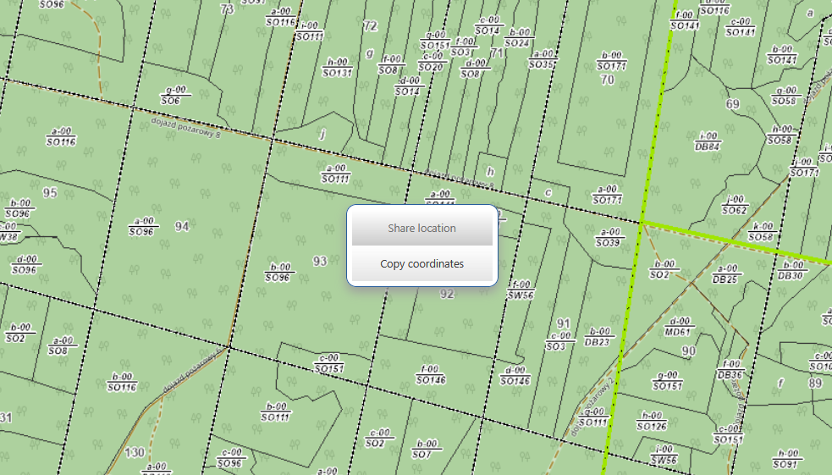

Copy coordinates
To copy coordinates on the BDL map, as in the case of sharing a location, right-click on the place of interest on the map, where a menu will appear, from which you select “Copy coordinates.” The coordinates of the selected point will be copied to the clipboard, and you can then paste them into a browser window, send them by email, etc.

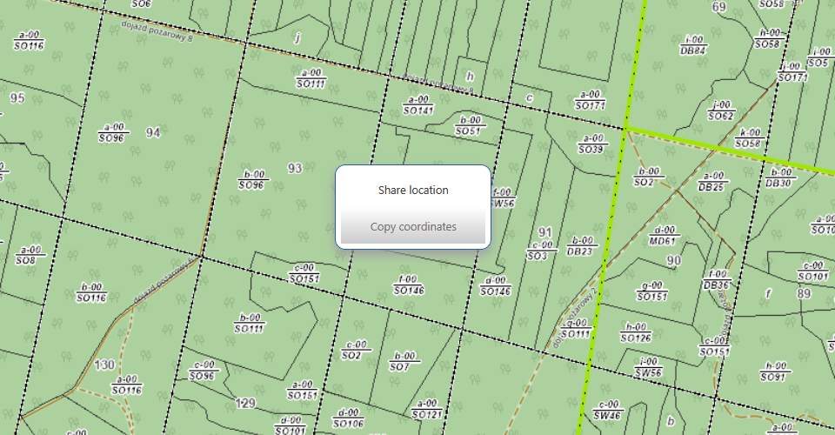

WMS/WMTS maps
The user can add a layer from the WMS service by clicking on the WMS/WMTS legend panel (GDOŚ, GUGIK, etc.). There are 7 permanently saved services that the user can activate by selecting the appropriate checkbox:

- Protected areas (GDFP)
- National Land Registry Data Integration
- Polish Waters
- State Register of Geographical Names (Geoportal)
- Raw materials - deposits, sites and mining areas
- Landslides and areas at risk of mass movements
- Digital Terrain Model

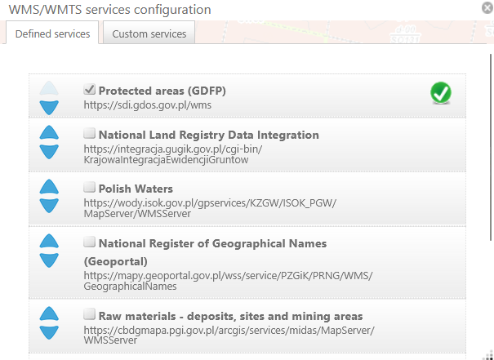

In the “Custom services” tab, the user can add any other WMS/WMTS address. All they need to do is paste the address, enter the name under which it will appear in the legend, and select the active layer to be displayed on the BDL interactive map.

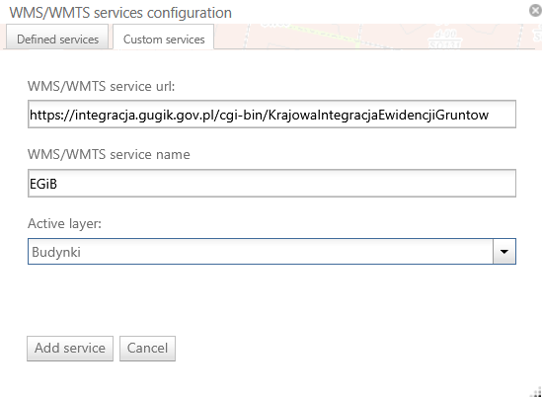

Individual layers can be enabled or disabled in the legend by selecting or deselecting the (checkbox). Right-click to remove a WMS/WMTS layer from the legend by selecting “Delete layer.”

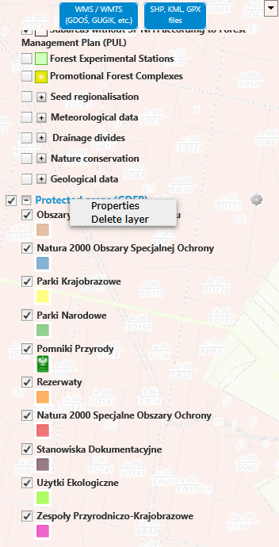

Loading and handling SHP/KML/GPX files
The BDL portal allows users to add a geometric layer in shapefile (shp) or KML/GPX format by clicking on “SHP, KML, GPX files” in the side panel. To add an SHP, KML, GPX file to the map, select the appropriate file on your computer's hard drive. Shapefiles should be compressed into a .zip file containing shp, dbf, shx, and prj files in PUWG92 or WGS84 format. After adding the file to the map, the user can change the layer parameters, such as fill color or no fill, outline color, and outline width.

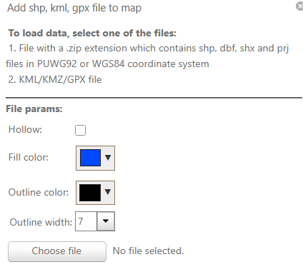

By right-clicking on the added layer, the user can zoom in, change layer properties, adjust transparency, color, labels, and fonts.
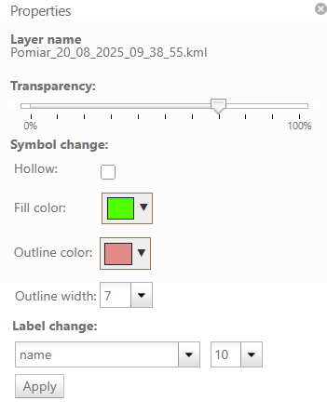

The process of adding KML and GPX files is similar to the procedure for adding SHP files.
The user also has the option of loading ZIP files, which contain both KML and GPX data.

Legend
The interactive map also features a “Legend” that explains the meaning of symbols used in BDL thematic maps. Each layer has a checkbox that allows you to enable or disable it. The legend changes automatically when any BDL map is selected. Some layers are grayed out (inactive) or invisible on the map depending on the user's zoom level on the interactive map.

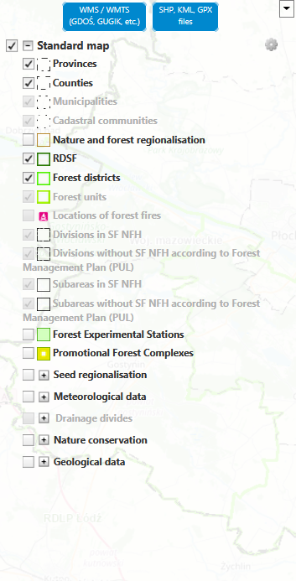

Reading selected information from the map
Clicking the left mouse button (LMB) on the map will display a window with a detailed description of the selected layers of a given thematic map. In the case of maps: standard, categories of property, and stands map, the description refers to a subareas. For other maps, the information will be adapted to their theme, for example: the hunting map contains descriptions of hunting grounds, the plant communities map contains information about forest communities, the fire roads map shows fire roads and locations of forest fires, the site map describes forest site, and the tourist infrastructure map shows tourist facilities. Depending on the selected thematic map, clicking the left mouse button (without activating any tool) allows you to read detailed information.

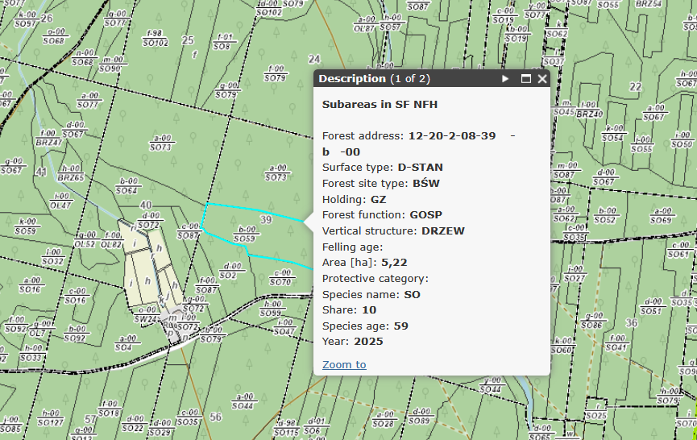
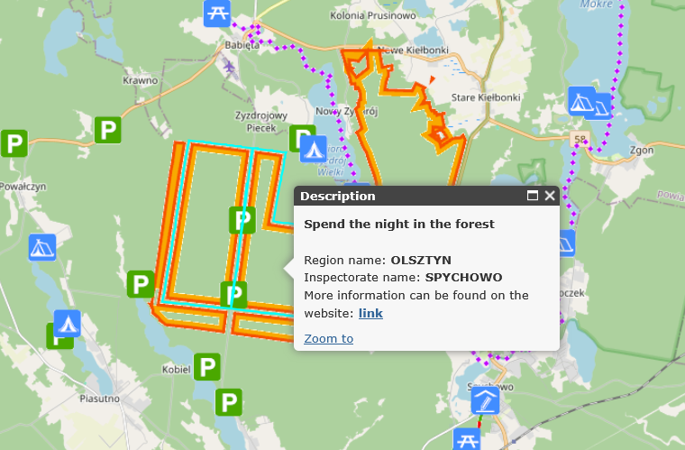

How to find areas for Spend the night in the forest?
To find areas covered by the “Spend the night in the forest” program, go to the bottom bar of the interactive map on the BDL Maps website and select the “Tourist infrastructure map.” The map will display tourist facilities, including those available under the “Spend the night in the forest” program.

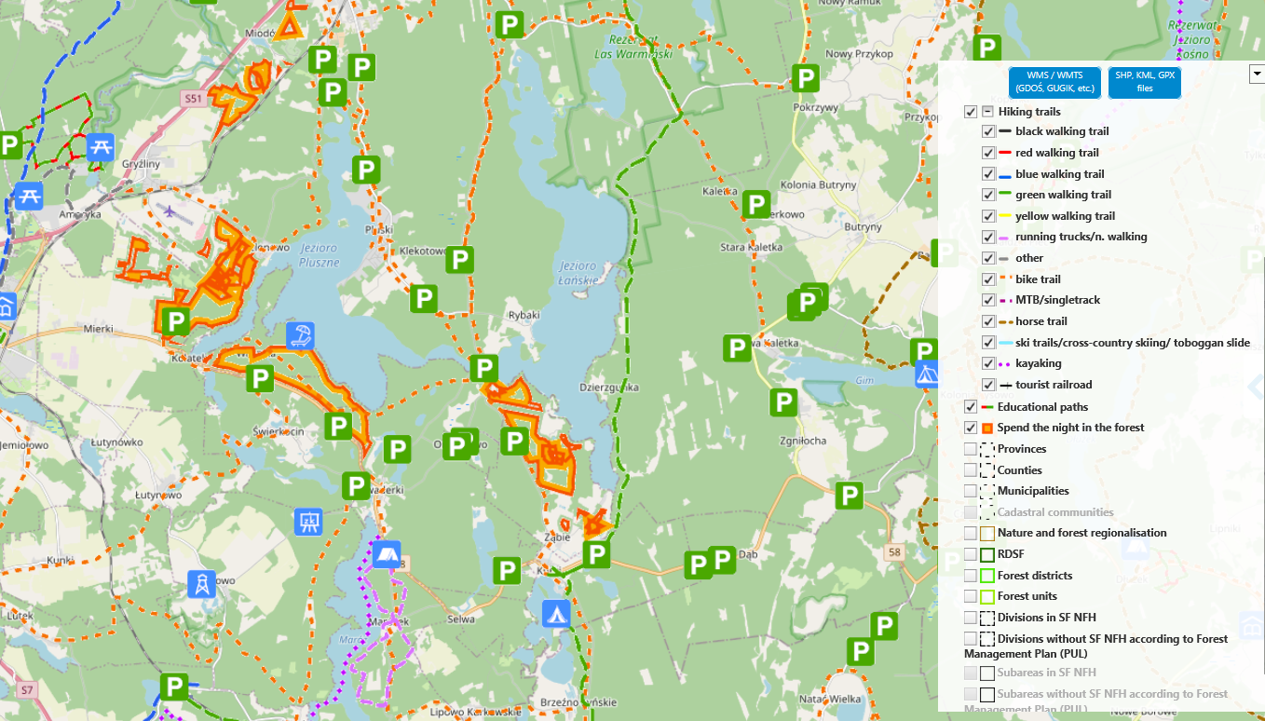

The legend shows how these areas are marked on the map. Using the “Identify” tool, you can click on a selected area to display basic information about the location covered by the “Spend the night in the forest” program.
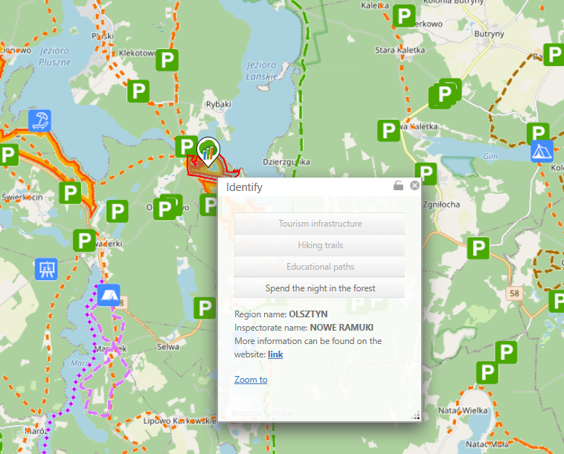

Language
The default language of the Forest Data Bank portal is Polish (PL). However, users can change the language to English (EN), which makes it easier for people who do not speak Polish to use the portal. The language change option is located in the left panel of the interactive map, in the drop-down list.

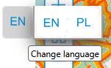

Help
In the left corner of the interactive map, there is a “Help” button, which acts as a guide to the available tools and functions. After clicking on it, the user receives detailed instructions and tips to facilitate the use of the map.

